Setup control shield
In this setup, the main requirements are:
Collect the data from the following sensors from different nature and actuate the following actuators:
- Mouse IR optical flow sensors (x and y displacements and rotation, which actually are the data coming from the x registers of the frontal and lateral sensors and the y register of one of one of the sensors).
- Licking sensor.
- External encoder position (actual motor position independent from the position sent to the motor).
- Pupil tracking camera.
- Water reward delivery by closing\opening a solenoid valve.
Communication with the computer that controls the virtual reality environment to send the position of the rodent on the two dimensional space and the yaw rotation of the animal. But also, receive the information of a certain events of the virtual environment such as a successfully or unsuccessfully accomplished task in order to apply a reward or a punishment for instance.
The experimental data is acquired simultaneously by a CED Micro 1401 ADC board [1] together with the microscope signal. Once the Arduino Due receive the data from the sensors that is converted to an analog output by three external DAC modules and the two DAC pins of the board (five signals). The Adafruit DAC module has been used because it has a different address than the other two DAC modules.
The Arduino DUE has been chosen because it is based on a 32bit microcontroller with 84 MHz clock, 96 KB SRAM, two DAC pins and I2C port, 800 mA DC current through the 5V pin [2].
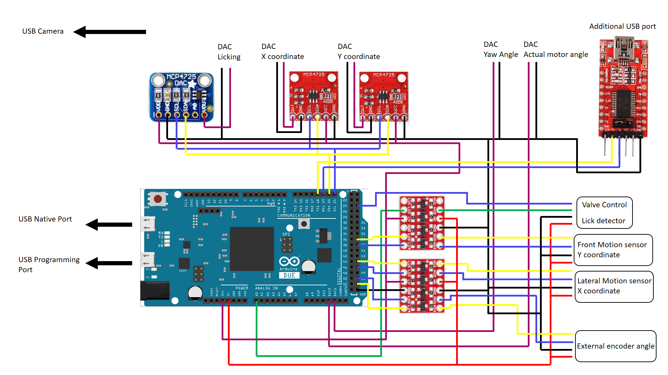
Figure 1: Arduino DUE conceptual schematic.

The signals coming from the sensors that are on the rotating platform use 6 signal wires: licking sensor, valve opening signal, clock and data from each motion optical flow sensor plus the 2 power supply wires (5V and GND) coming from the Arduino.
In order to make an easier system to connect the board with the sensors and the CED board connectors a PCB board has been designed. The board has screw connectors to make easier the connections from the sensors to the pins without being accidentally disconnected during the experiments and also, male BNC connectors to connect BNC female cables from the microcontroller to the Micro 1401 board.
The camera is connected independently to the computer using the slip ring USB cable.
The other microcontroller considered for the setup is the powerful Teensy 3.6 [3] with 180 MHz clock, 256 KB RAM, two DAC pins, 1m Flash memory, multiple UART and I2C ports and the possibility to increase the I2C transfer speed (Figure 2).

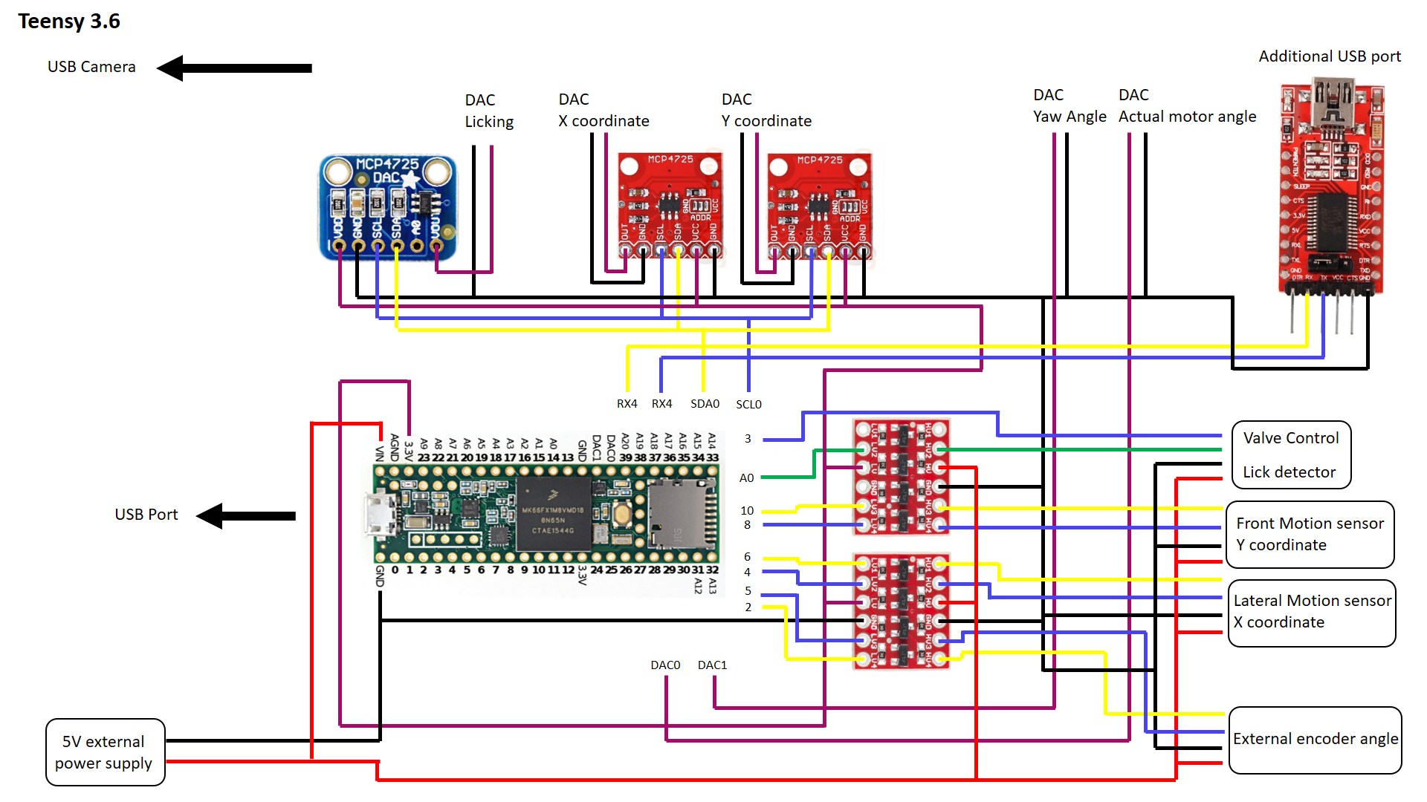
Figure 2: Teensy 3.6 conceptual schematic.
The chassis of the DT240 rotary stage must be connected with the ground of the Shield (Motor GND) in order to have the same GND for both systems. The 5V and the GND signals on the Figure 3 are the connections with the elements over the rotary platform connected using the wires of the rotary joint. The D12 and D13 pin connections are made to connect the capacitive sensor of the capacitive reward delivery system.
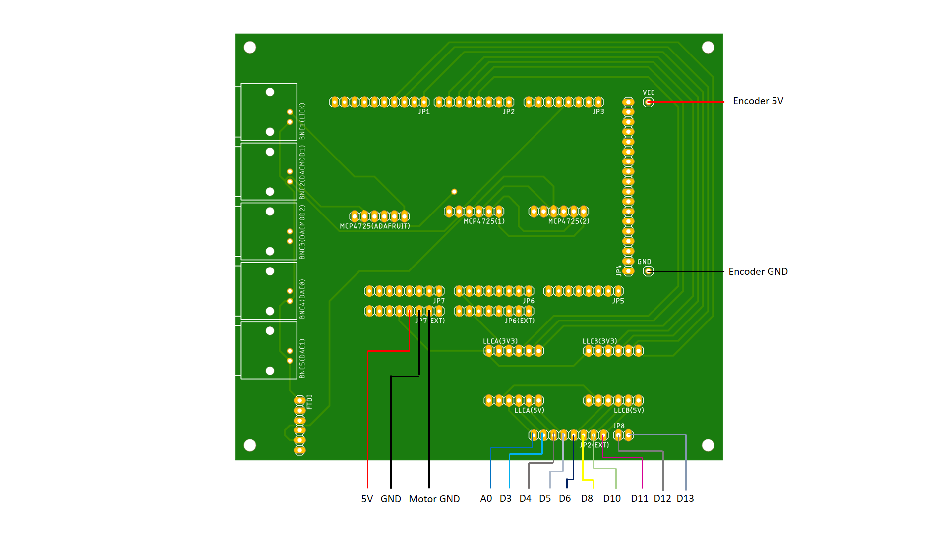
Figure 3: Arduino DUE shield pin connections relationship.
In order to get two different addresses with the two DAC MCP4725 modules (the red ones) in one of them, the ADDR Vcc pin must be soldered with the central pin.
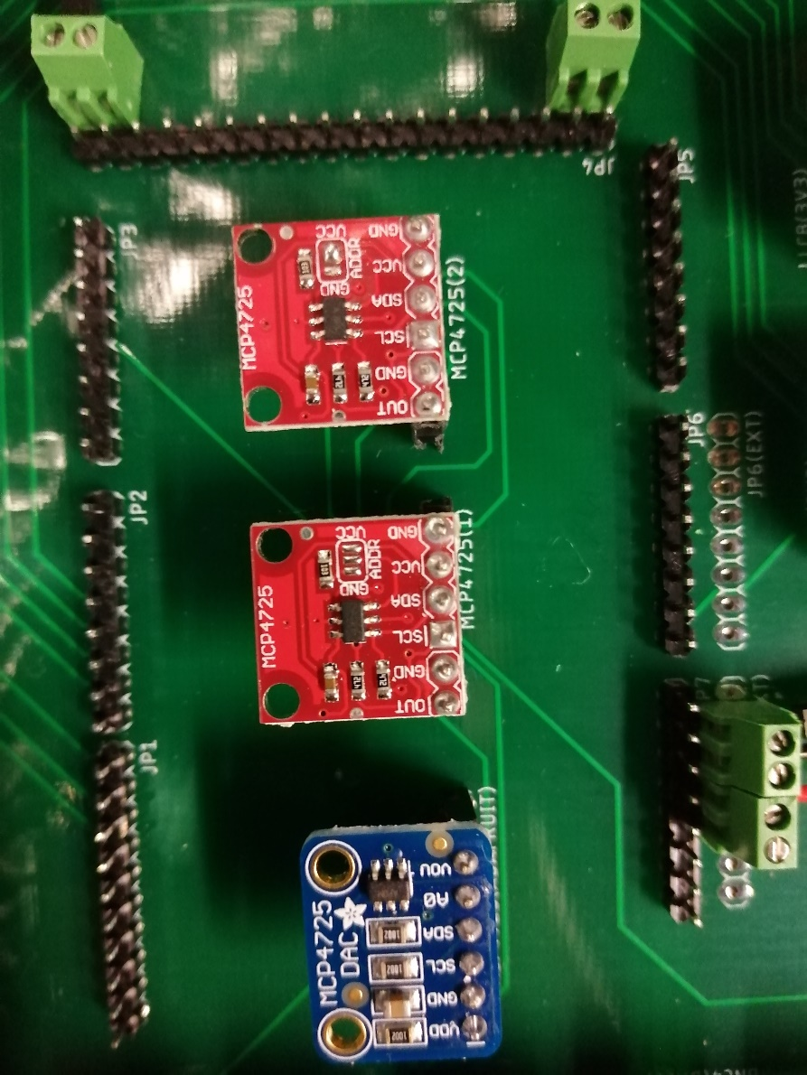
Figure 4: DAC module Central SDDR pin soldered with the right (Vcc) pin.
With this combination we get three different modules with three different addresses:
- Standard MCP4725 module address: 0x60.
- Modified MCP4725 module address: 0x61(Vcc pin soldered with the central pin).
- Adafruit MCP4725 module address: 0x62.
For both boards, the logic level shifters TE291 [4] are needed to convert the 3.3V signals to 5v signals and vice versa. These components must be soldered with the electronics components facing down (Figure 3)
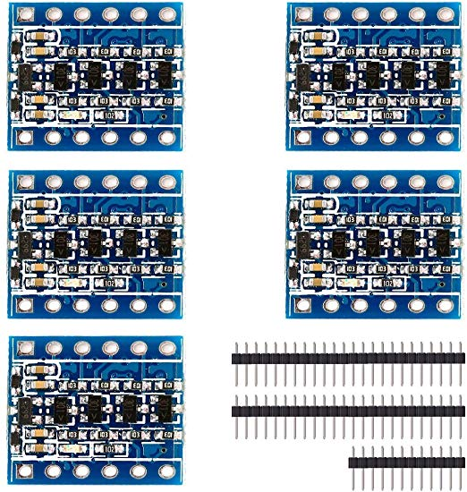
Figure 5: Logic level shifter and position on the board.
There is also an extra USB port connection to the Serial1 in case more than one port is needed. For this purpose, a TTL to USB FTDI converter (Figure 1) must be used with the 3.3V configuration instead the 5V configuration [5].
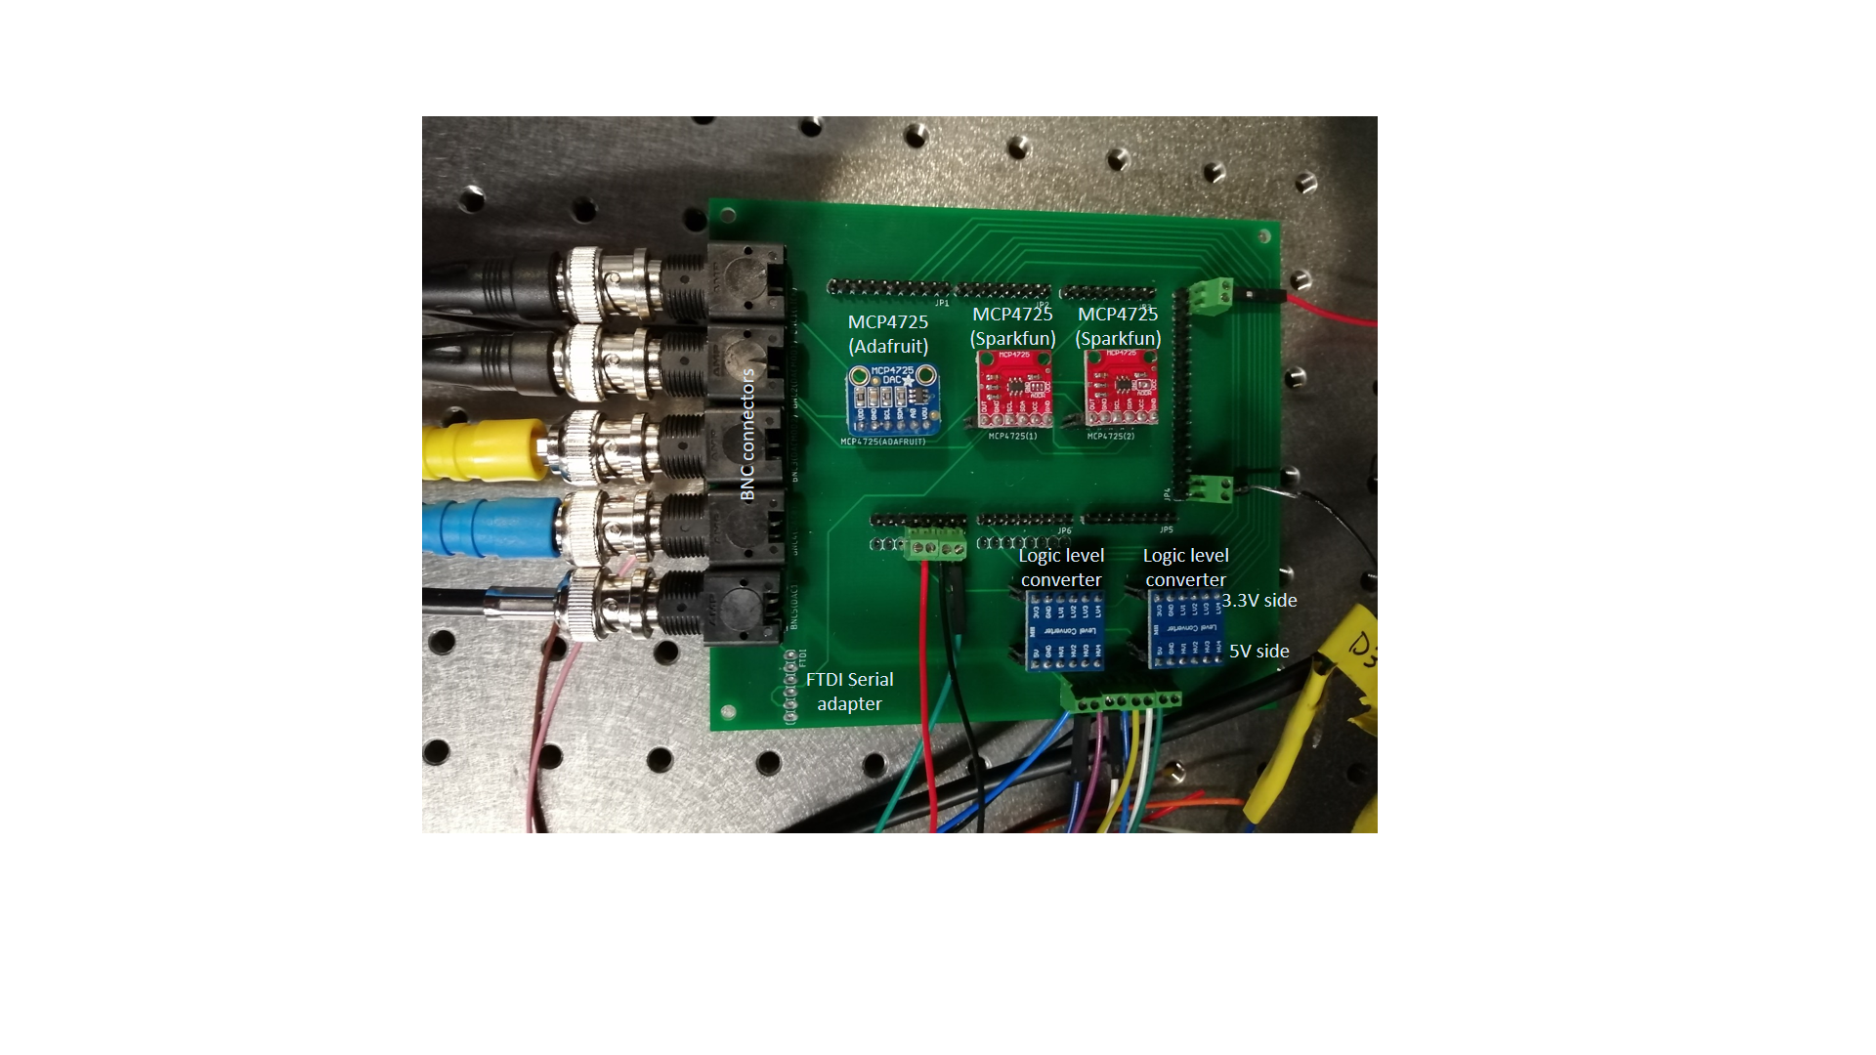
Figure 6: Arduino DUE shield manufactured and connected with the setup.
The board can also be manufactured using screw connector with the Shield case.STL (Figure 7):
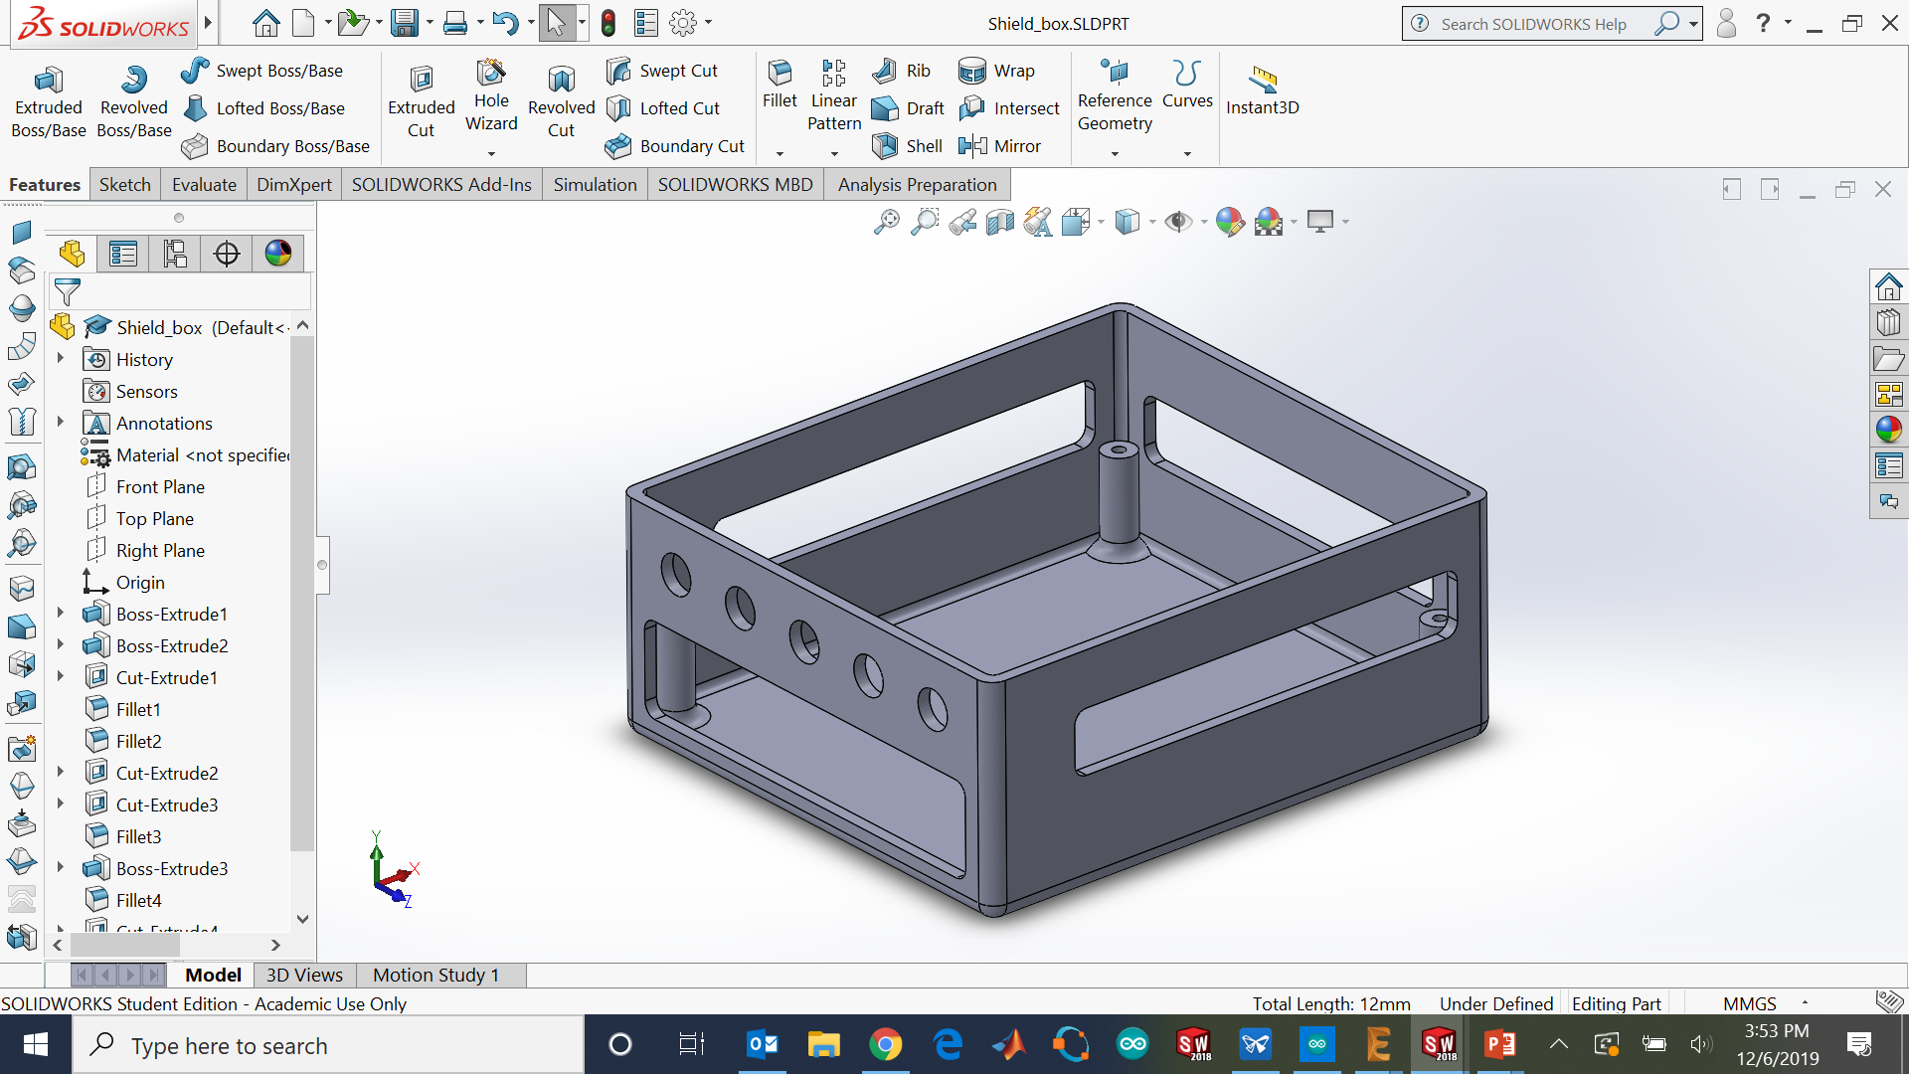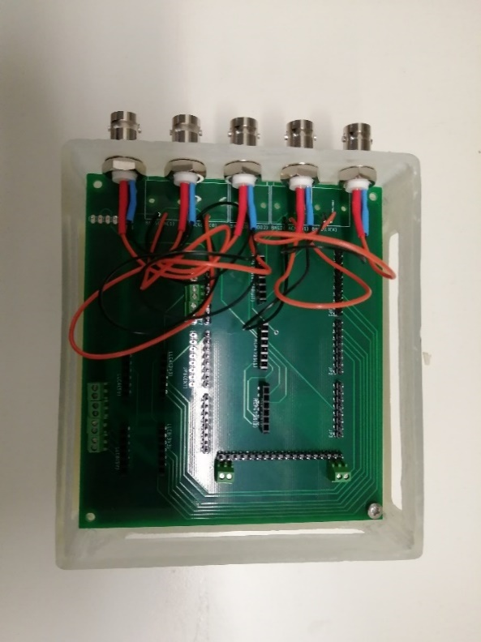
Figure 7: PCB and shield case manufactured.
The Teensy 3.6 shield must be connected to an external 5V power supply in order to get the voltage needed to operate the optical sensors, the encoder and the reward delivery system (Figure 8).
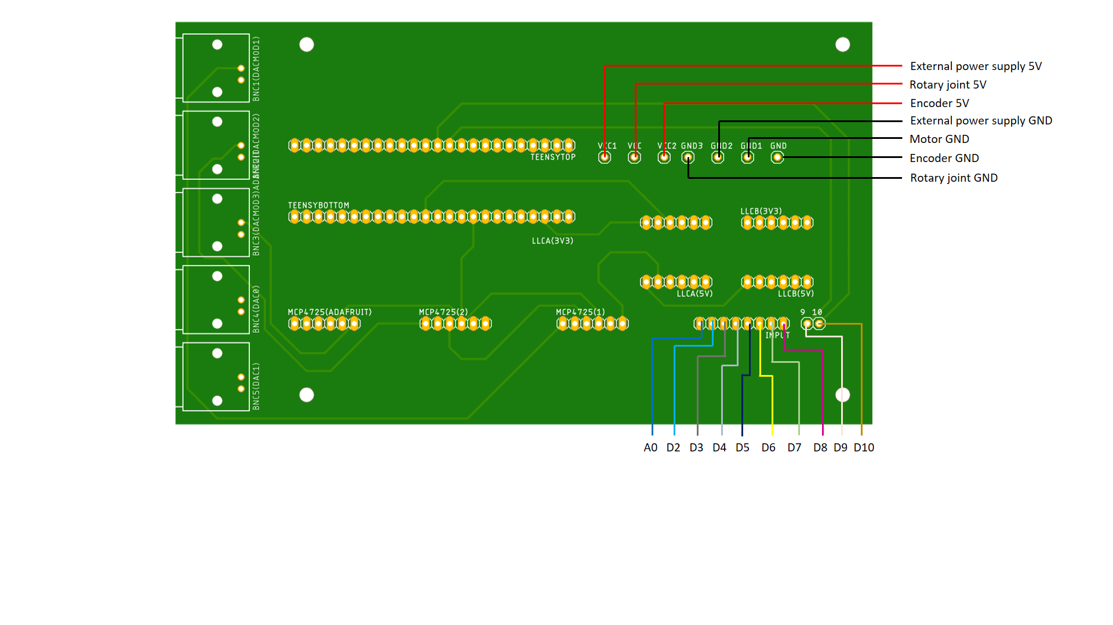
Figure 8: Teensy 3.6 shield connections.
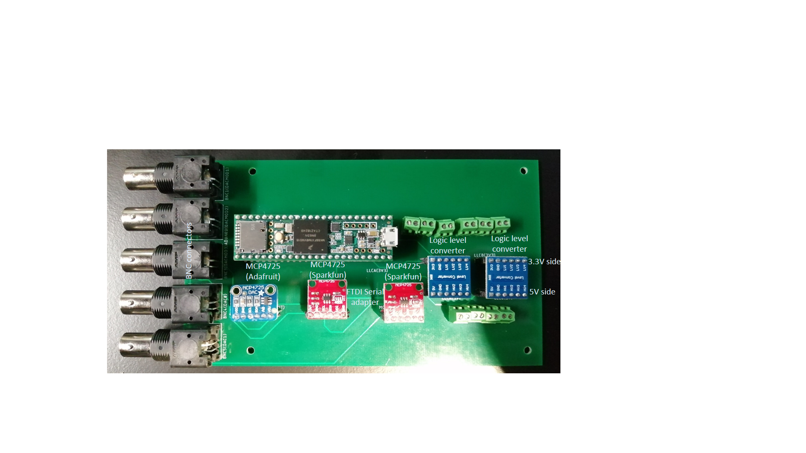
Figure 9: Teensy 3.6 shield manufactured.
The Teensy 3.6 has not only a faster clock, there is the possibility to increase the rate of the I2C communication up to 4.5M (Figure 10).
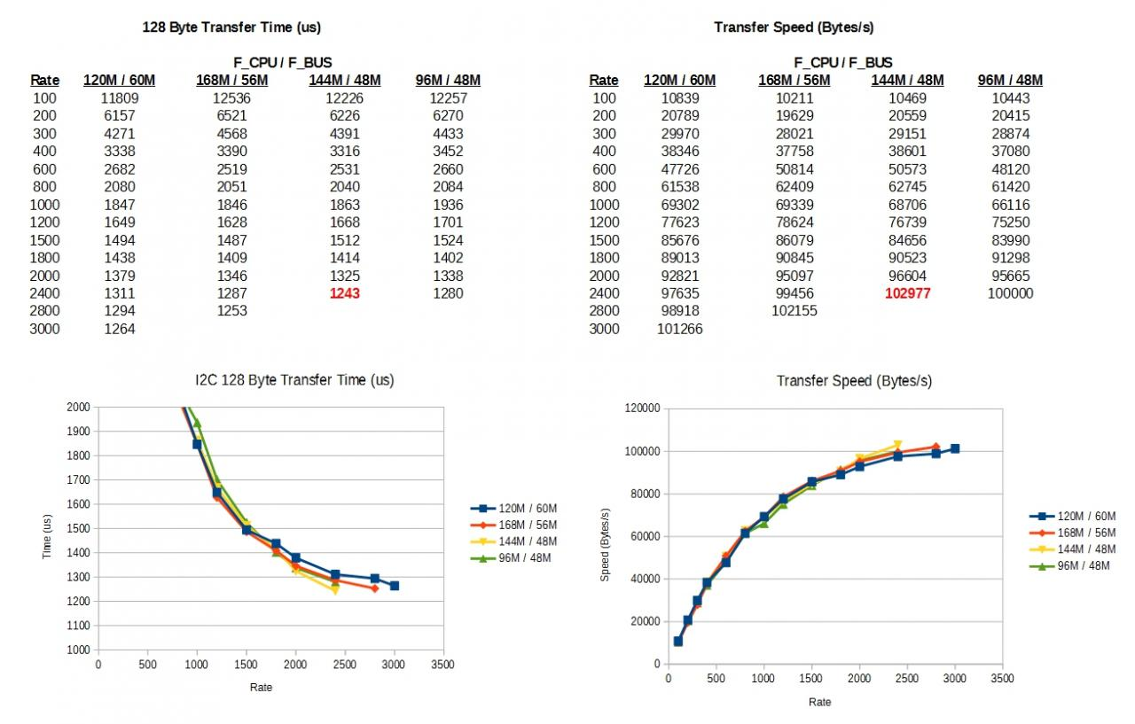
Figure 10: I2C transfer speed [6].
WARNING: The teensy 3.6 has not been implemented yet.

Bill of materials
The materials needed for any of these two boards are the following:
Component | Quantity | Supplier | Reference
Board | 1 | - | Gerber files (DUE or Teensy 3.6)
Shield case | 1 | - | Shield case.STL
BNC connector | 5 | RS components | 546-4910 or 526-5864
Female pin header | - | - | -
Male pin header | - | - | -

References

[1] | "http://ced.co.uk/products/mic3in," [Online].
[2] | "https://store.arduino.cc/due," [Online].
[3] | "https://www.pjrc.com/store/teensy36.html," [Online].
[4] | "https://www.amazon.co.uk/gp/product/B0148BLZGE/ref=ppx_yo_dt_b_asin_title_o02_s00?ie=UTF8&psc=1," [Online].
[5] | "https://www.amazon.co.uk/AZDelivery-FT232RL-Adapter-Arduino-Raspberry/dp/B0753GY7FR/ref=sr_1_1_sspa?keywords=FTDI+ttl&qid=1575365699&s=electronics&sr=1-1-spons&psc=1&spLa=ZW5jcnlwdGVkUXVhbGlmaWVyPUFDNVBOTDBXTTgwVTUmZW5jcnlwdGVkSWQ9QTAwMTE0MzMyMzJEQTFHTFhF," [Online].
[6] | "https://forum.pjrc.com/threads/21680-New-I2C-library-for-Teensy3," [Online].

